Portable Cell Initiative

Antenna Analysis for Microcells

By: Arpad Kovesdy

**Summary**

The antenna’s design, provided a 30 m elevation from a real ground, provides an isotropic gain that varies from 6.48 dBi for the downlink antenna to 7.25 dBi for the uplink antenna based on computer models in 4nec2 (a computer program). Radiation patterns modeled support the antenna theory of horizontal omnidirectionality, even in different environments. The antennae standing wave ratios are at a manageable value of 1.18 based on the average operating frequency used and a 50 Ω coaxial cable feed line. Other factors such as feed line attenuation are also explored further.

**Basic Antenna Configuration**

The microcell’s base station for GSM communications consists of two antennas: one for uplink (handling radio communications the mobile user to the microcell) and one for downlink (microcell to the mobile users). For both antennae, there are two portions: a conducting and a grounding region. In a classic half-wave dipole antenna that is pointing vertically and is thus vertically polarized, the feed point will be at the middle of two conductors pointing towards the ground and towards the sky. The vertical polarization is common in mobile systems because “vertical polarization has somewhat lower attenuation over terrain”[1].The radiation pattern of this type of antenna is a donut shape that projects most of the radiation perpendicular to the conductor. To lower the impedance to the characteristic impedance of the feed line (which is 50 Ω), from the antenna impedance of a dipole, the grounding portion is raised closer to be 30° below the horizontal. In total, there are three conductors that point out from the center to form the grounding portion to improve omnidirectionality. Here is an image of the projected geometry with wires in gray and axes in green:

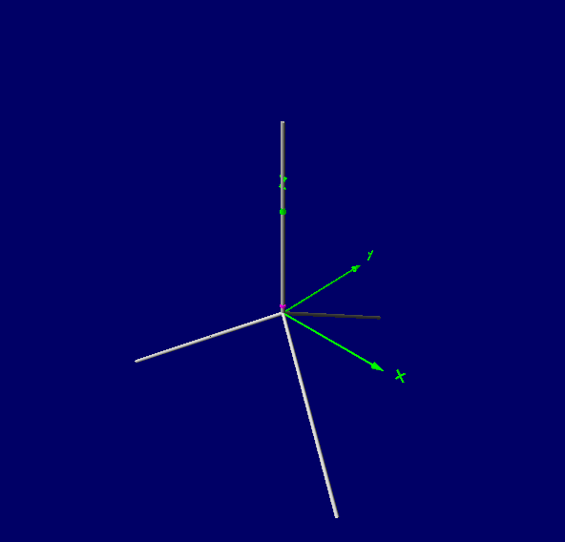

**Antenna Characteristics**The length of the antenna conductors (which is around a quarter of the wavelength of the transmitted or received radio wave since the complete system is based on a half-wave dipole design) is given by the following equation[2]:

The following characteristics of the antennae were calculated based on simulations in 4nec2, a program for showing how EM radiation is generated by different antenna geometries. The same simulations were also conducted over a 30 m real ground, which offers more realism than the simulation of the antennae in free space (an environment that does not practically exist). The diameter of the wires used in the antennae is 0.81 mm, which is the same size as the core of a common 50 Ω coaxial cable (RG-58 U). The following tables show the various characteristics that were computed using the computer models:

|  |  |
| --- | --- |
| Characteristic | Value |
| Transmission frequency range | 890 – 915 MHz |
| Average operating frequency | 902.5 MHz |
| Wavelength | 0.332 m |
| Monopole length | 0.07903 m |
| Number of monopoles | 4 |
| Isotropic Gain in Free Space | 1.77 dBi |
| Isotropic Gain above a 30 m real ground | 7.25 dBi |
| Relative Directivity Factor | 9.67 |
| Impedance | 44.1 Ω |
| Radiated Efficiency (30 m above real ground) | 59.47 % |
| S.W.R. (50 Ω feed line) | 1.18 |

Table 1: **Uplink** Antenna Characteristics

|  |  |
| --- | --- |
| Characteristic | Value |
| Transmission frequency range | 930 – 960 MHz |
| Average operating frequency | 945 MHz |
| Wavelength | 0.317 m |
| Monopole length | 0.0755 m |
| Number of monopoles | 4 |
| Isotropic Gain in Free Space | 1.77 dBi |
| Isotropic Gain above a 30 m real ground | 6.48 dBi |
| Relative Directivity Factor | 8.74 |
| Impedance | 44.3 Ω |
| Radiated Efficiency (30 m above real ground) | 59.43% |
| S.W.R. (50 Ω feed line) | 1.18 |

Table 2: **Downlink** Antenna Characteristics

The following images depict the radiation patterns of the uplink antenna (which are very similar for the downlink antenna) in different environments. There are 3D plots which show the area around the antenna and 2D plots which show the patterns from a vertical and horizontal aspect. The first two images are in free space and the second two are when the antenna is 30 m above real ground.

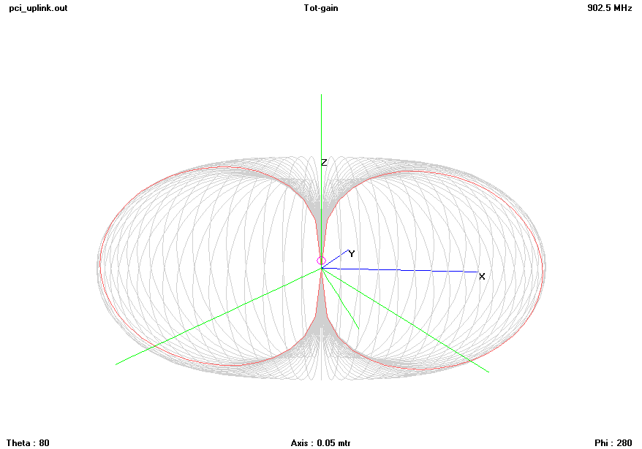

Image 2: Radiation Pattern (Uplink) in free space

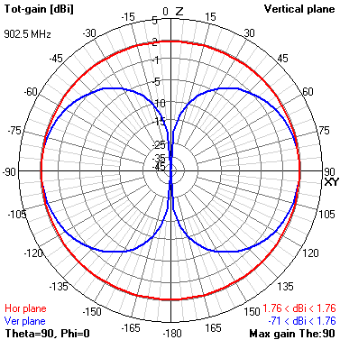

Image 3: Radiation pattern (uplink) from the vertical plane’s perspective in free space

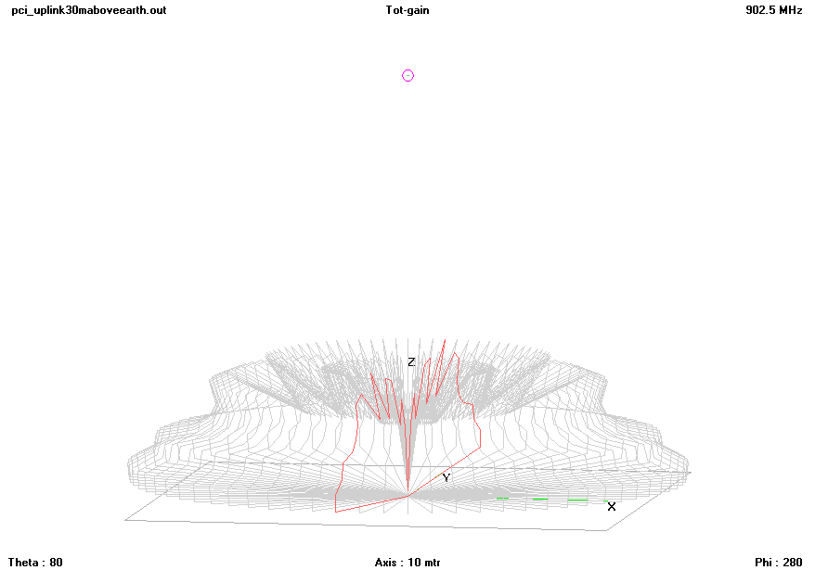

Image 4: Radiation pattern (uplink) when the antenna is 30 m above real ground

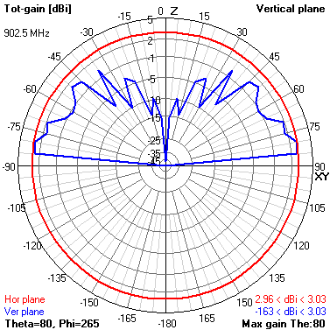

Image 4: Radiation pattern (uplink) from the vertical plane’s perspective when the antenna is 30 m above real ground

|  |  |
| --- | --- |
| Characteristic | Value |
| Dielectric Constant | 13 |
| Conductivity | 5.0 x 10-3 Mhos/meter |

Table 3: Real ground properties (average)

**Other Considerations**

When constructing the tower upon which to mount the uplink and downlink antennae, it is important that any conducting materials, like guy wires, extra cables, and metal supports, should be separated from the antennae to prevent electromagnetic interference. Additionally, the antennae should be separated by several wavelengths to reduce interference further, since the two antennae transmit or receive on similar frequencies.

It is therefore highly recommended that the antenna and antenna tower be mounted on an elevated building to reduce the necessary support required. Additionally, there will also be a loss in gain (nominal attenuation) in the coaxial cable that connects the amplifier to the antenna. This is equivalent to around 13 to 16 dB/100 feet of coaxial cable in frequencies around 1000 MHz[3]. It is recommended that this cable be as short as possible.

Overall, the antenna gain varies dramatically based on the surface under the antenna and the elevation. The characteristics also depend on the environment (buildings, hill, etc.) and tower configuration (conductors, cable lengths, etc.) that surround the antenna. The simulation showed an antenna gain of 1.77 to 6.5/7.3 dBi based on different environments. In further calculations, we will continue to reference the standard value of 2.16 for monopole antenna systems with virtual grounds as a “worst case scenario”

1. http://people.csail.mit.edu/bkph/cellular_repeater_outside.shtml
2. Silver, H. W. (2007). The ARRL general class license manual. Newington, CT: ARRL.
3. www.prioritywire.com/specs/c-3.pdf